# **Setting up a Professional Data Science Environment - Configuring Git and Anaconda**

1. Install Git and Anaconda
2. In your terminal window*(the Terminal app for Mac, and the Git Bash program for Windows), type git config --global user.name
   1. If it returns your name, you’re set!
   2. If it returns nothing or displays an error message, type git config --global user.name “Your Name” - replacing Your Name with your name inside the quotes (this should be your real first and last name, not your GitHub username)
3. In your terminal window, type git config --global user.email
   1. If it returns your email address, you’re set!
   2. If it returns nothing or displays an error message, type git config --global user.email your@email.com - replacing your@email.com with your email address

## **Cloning this Repository**

1. Open a new terminal window
2. Type pwd - this should show your home directory, the most basic of paths on your computer
3. Type cd Documents - this will change your directory, and move you into your Documents folder
4. Type mkdir Flatiron - this will create a new folder, called Flatiron, to keep all of your Flatiron repositories and files
5. Type cd Flatiron - this will change your directory, moving you into the new Flatiron folder you just created

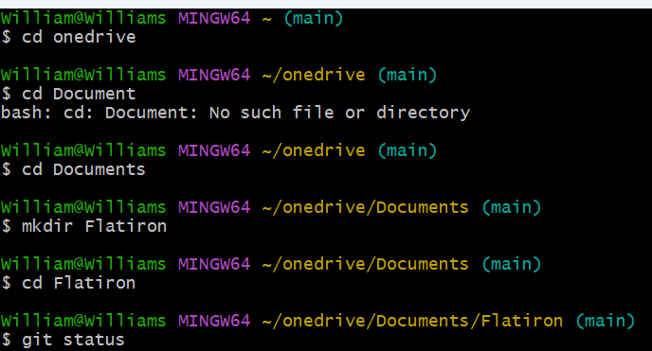

Clone once you in Flatiron directory

git clone <https://github.com/learn-co-curriculum/dsc-data-science-env-config.git>

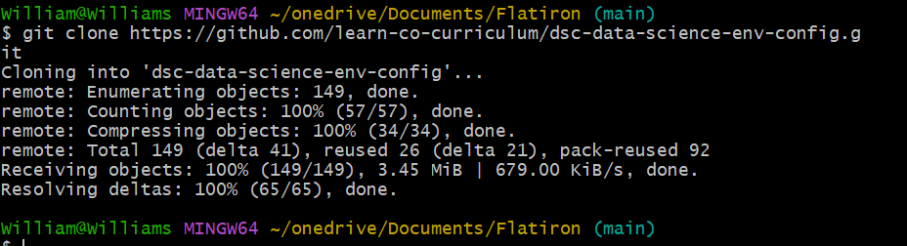

The clone above will create a new subdirectory whose name is "dsc-data-science-env-config" which will contain a copy of all of the files in this repository!

Move to this dsc-data-science-env-config subdirectory using

Cd dsc-data-science-env-config.

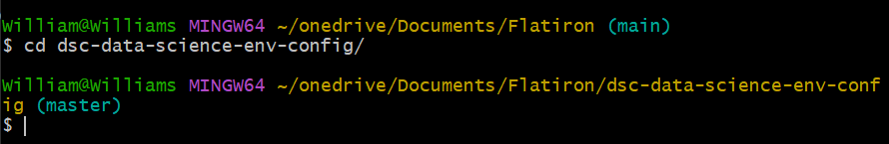

Now create the virtual environment. It it doesn’t work then check below.

### **Creating the Conda Virtual Environment**

First ensure the path is included..

1. Verify PATH Environment Variable:
   * If you have Anaconda installed, ensure its path is included in your system’s PATH variable:
     + Windows:
       - Open System Properties (search for “environment variables”).
       - Under “Advanced” tab, click “Environment Variables”.
       - Edit the “Path” variable and append the path to your Anaconda installation’s Scripts directory (e.g., C:\Users\YourUserName\Anaconda3\Scripts).# change yourusername with your named laptop username. Check this on you laptop

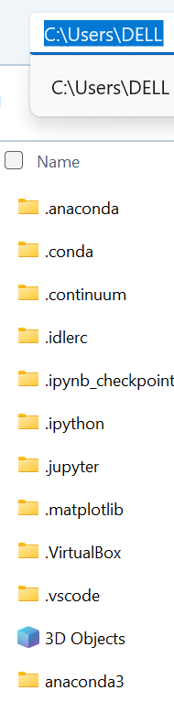

* + - macOS/Linux:
      * Open terminal and edit your shell profile file (e.g., ~/.bashrc or ~/.zshrc).
      * Add this line: export PATH="/path/to/anaconda/bin:$PATH" (replace with the actual path).
    - Restart your terminal session for changes to take effect.

You can now create the venv using gitbash in windows

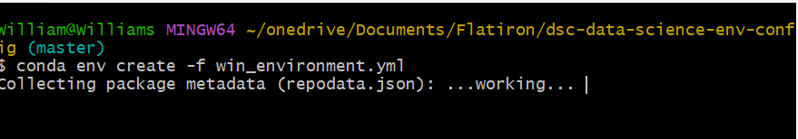

After the it’s done, check and update the env using conda env list command.

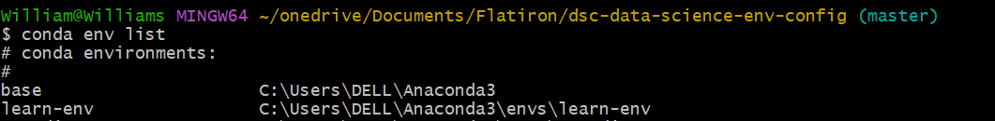

Update anaconda and Initialize the env first if you face issues doing so.

1. Update using

conda update conda

1. Initialize the bash

conda init bash

Once done ensure to exit the bash and restart for the changes to take effect.

Activate the environment



To confirm it worked

To confirm that it worked, type conda info --envs and confirm that the asterisk (*) is next to the learn-env environment.

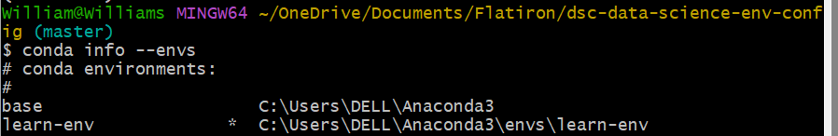

## **Setting your Default Environment**

You have successfully created your virtual environment! But, to be sure that you are using the learn-env, it's helpful to set it as your default environment so that you don't need to remember to manually switch to it every time you open the terminal. This step is **highly recommended** but not required.

### **Windows**

To follow these instructions on a Windows machine you must be using the Git Bash shell it was suggested to install above.

1. Run touch ~/.bash_profile to create a new file.
2. Run echo "conda activate learn-env" >> ~/.bash_profile to add the configuration to your bash profile
3. Run source ~/.bash_profile to activate the changes you just made